**ANALYSIS - PERFORMANCE OF A MARKETING CAMPAIGN**

**Background:**

A company has deployed a marketing campaign to increase user engagement with its Brand, convert them into customers and generate more sales for their products. It has used diverse channels to deliver the campaign and is now trying to understand whether the money and efforts spent to do so have converted into gains. This will help the company understand the performance effectiveness of such types of events in terms of ROI & take decision on whether to allot budget for more such campaigns in the future based on current key findings

**Agenda:**

We’ll do a comprehensive analysis of the campaign data to understand whether the actual numbers have met the initially projected targets.

**Key Metrics to Analyze:**

* User Engagement – Find the Engagement Rate
* Conversion rates - % of engaged users that converted into buyers
* Impact on Sales – Increase or decrease in Sales after the Campaign
* ROI on marketing spend – Return on Expenses incurred. Comparison to previous Campaigns

**Pre-Defined Targets & Other Information:**

* Targeted Customer Reach – 1500
* Conversion Rate – 35%
* Campaign budget - $50000

**Previous Campaign Information:**

* Revenue generated - $268000
* Campaign Budget - $57000

**Available Data:**

1. UserInteractions – This dataset contains all details about user engagement
   * + User Unique Identifier
     + Date of Interaction
     + Point of Contact Channel category like Email, Website, Social Media
     + Action (Interaction category) – Click, View, Share
2. SalesTransactions – Contains details about every Sales transaction that was a result of the Campaign
   * + Transaction Id
     + Date of Transaction
     + Customer Identifier
     + Product Identifier
     + Product Category – Books, Clothing, Electronics, Home & Kitchen, Sports, Toys
     + Sales Amount
     + Quantity

ANALYSIS

**Step 1:** Load data into Jupyter Notebook

**Step 2:** Clean the Data

1. Check datatype correctness

-Changed Date columns from object type to Datetime

ii) Null Check & Handling Missing Data

-Replace NULL fields with the most representative value as the column was Categorical

-In case of numeric fields we could replace NULL with mean, median etc.

**Step 3:** Analysis

1. Calculate User Engagement Rate

* Engagement is defined as the number of customers that engaged with our campaign communications
* 66.67% of Target is achieved
* The campaign hasn’t performed as well as expected in terms of User Engagement

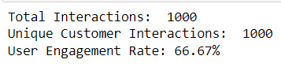 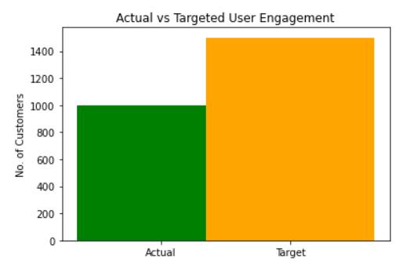

1. Calculate Conversion Rate

* Merge Sales table with User Interactions table, find common customers
* Select the customers who made a purchase after their interaction with Campaign
* Find all such unique customers and calculate the Conversion Rate

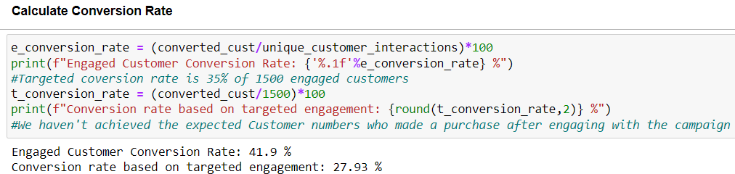

1. Impact of Campaign on Sales

* Determine the period ranging the Sales dataset
* Calculate total Sales amount for each transaction

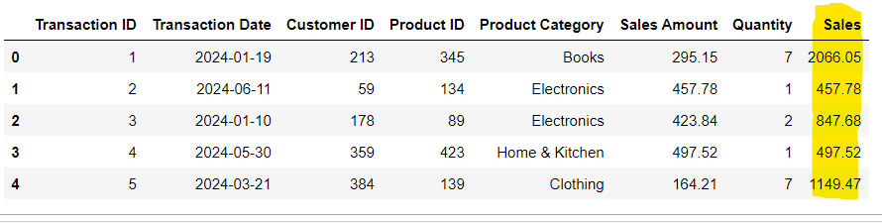

* Calculate Sales during & after the campaign
* Calculate sales growth rate during the campaign period
* The campaign had a positive impact on Sales as they increased during the period

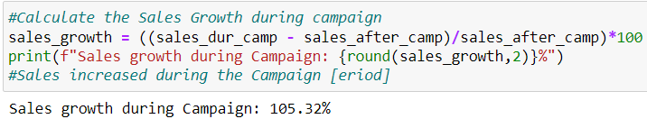

1. Compare ROI of this Campaign with the last one

* Previous Campaign budget was $57000 & revenue generated $268000
* Current Campaign budget is $50000
* Calculate revenue generated by this campaign

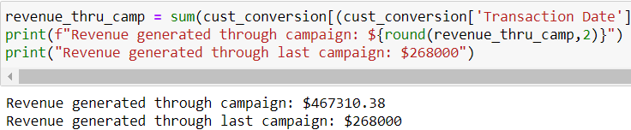

* Calculate ROI on current & previous Campaigns

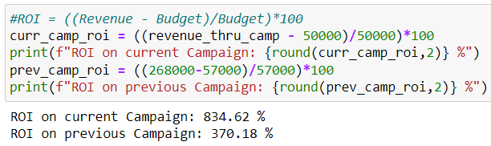

* This Campaign has given a better return on investments